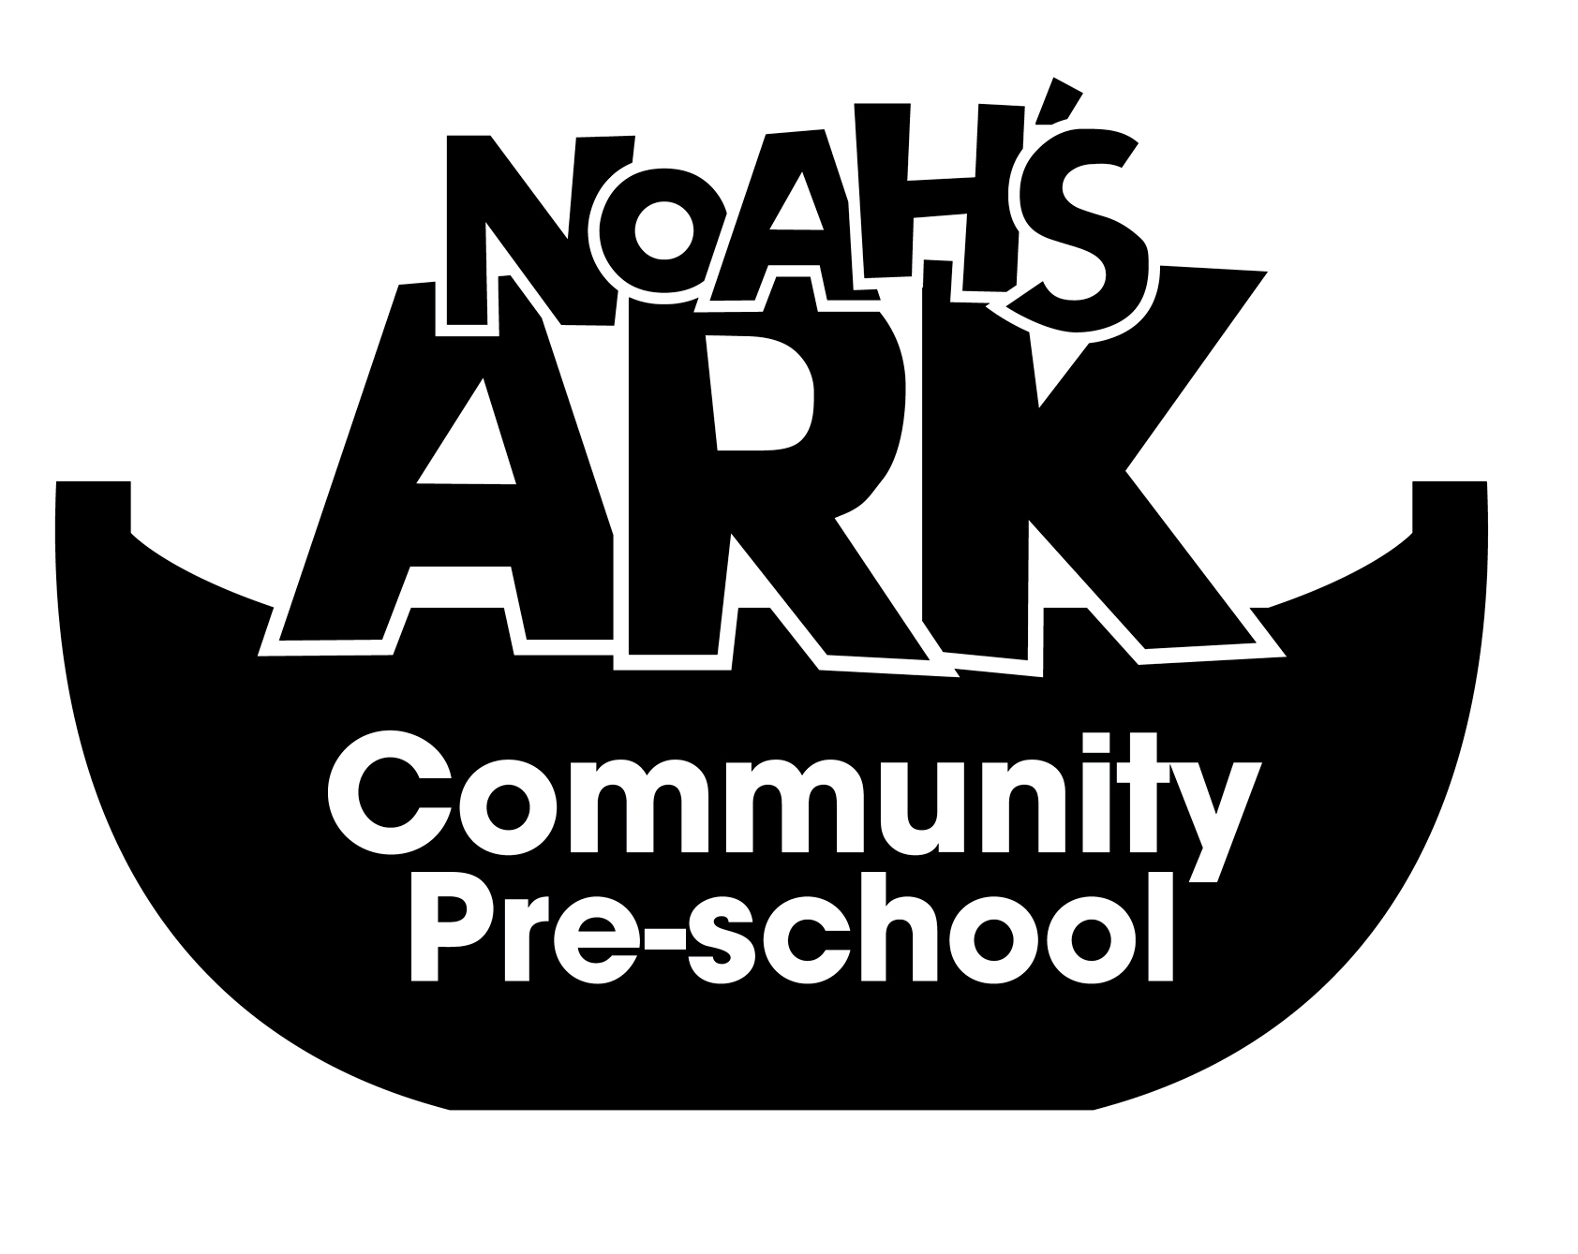

NOAHS ARK COMMUNITY PRE-SCHOOL
15. HEALTH POLICY
(September 2025)

FOOD

Parents will provide a packed lunch for the children that stay for lunch club. All meals provided by parents should be healthy and within our policies and procedures.
All snacks will be healthy, including crackers, fruit and raw vegetables.
All food will be checked for gelatine content.
Any food brought in by parents or carers for special occasions will be checked before being given to the children.
Children will be encouraged to sit down to eat. Food will be cut small to avoid choking.

OUTDOOR PLAY
Depending on the weather, children will have the opportunity to play in the garden every day. They will be encouraged to put on their own coats, hats and gloves.
Children will be encouraged to wash their hands after playing in the garden.

ILLNESS
We will comply with PHE guidelines regarding infectious diseases.
Parents and carers are asked to keep their children at home if they have an infection.
Parents and carers are asked to inform the playgroup of the nature of the infection so that the staff can alert other users and make careful observations of any child who seems unwell.
Parents and carers are asked not to bring any child into the Pre-School who has vomited or had diarrhoea in the previous 48 hours.
Staff will not bring their own children to work if they are unwell.
Cuts and open sores on adults and children must be covered by a plaster or dressing.
If a child is on a prescribed medication, the parent or carer may be asked to administer it. If not, please see medicines administration policy.
The Pre-School will maintain links with health visitors and local health care services.
Parents and carers are able to discuss health issues with Pre-School staff and have access to information that is available to the Pre-School.

This policy is reviewed annually
3rd September 2025

Signed on behalf of the Pre-School:
Position: Manager

