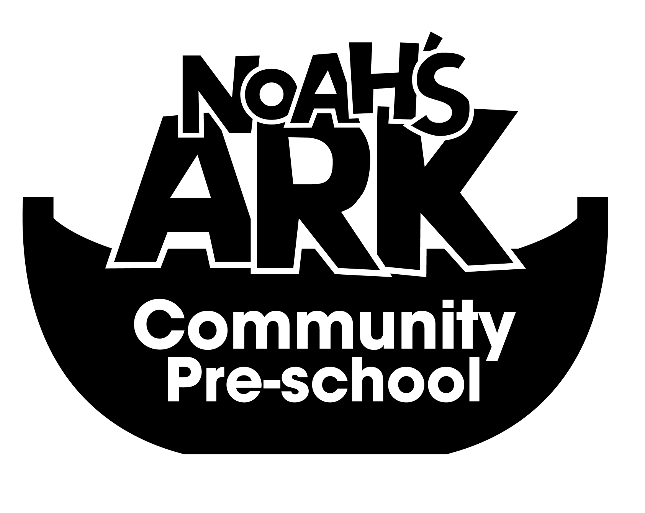
NOAHS ARK COMMUNITY PRE-SCHOOL
11. DIET- POLICY AND PRACTICE
( 3rd September 2025)

The sharing of refreshments can play an important part in the social life of the Pre-School as well as reinforcing children’s understanding of the importance of healthy eating.
The Pre-School will ensure that all snacks will be healthy including, crackers, fruit and raw vegetables.

Only food that has been bought and prepared by the staff will be offered to the children.

Children’s medical and personal dietary requirements are respected.

Children have the opportunity to taste food from a variety of cultural backgrounds.

No food containing, meat, fish, nuts or gelatine will be offered to the children.

Any food brought in by parents or carers to celebrate a special occasion, will be checked before being given to the children.

Water is available at all times. Milk is provided or Soya if necessary and the nursery is informed.

This policy is reviewed annually
Date: 3rd September 2025

Signed on behalf of the Pre-School:
Position: Manager

