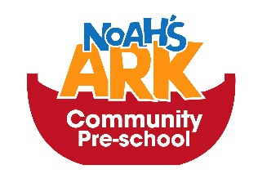
Snacks and Lunches
Dear Parent/Guardians
We will be asking for a 50p daily contribution towards snacks per session at the start of each week so if your child has 5 x 3hour sessions we would ask for £2.50.
The money will be collected on the first session of the week that your child attends and we will collect the whole week’s contributions.
This money is used for snacks and drinks during the sessions and some of the cooking activities which the children really enjoy.
We would also like to remind parents that we do not cook food on premises, which means lunch boxes should be prepared in advance with healthy treats.

Thanks for your continued support
Atiq Chowdhry

