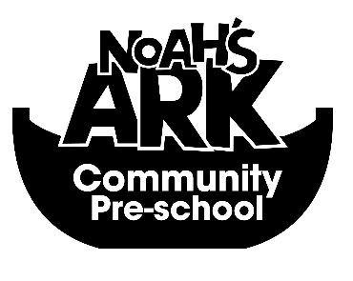

Dear Parents,
At Noah’s Ark Pre-School we plan to celebrate all festivals, celebrated by people all over the world. Please could you state if you would like your child to help celebrate them with us, through a range of activities.
Celebration | Please tick
Halloween
Eid
Christmas
Hanukkah
Diwali
Easter
Chinese New Year

Child’s Name_______________________________

Parents Signature____________________________

