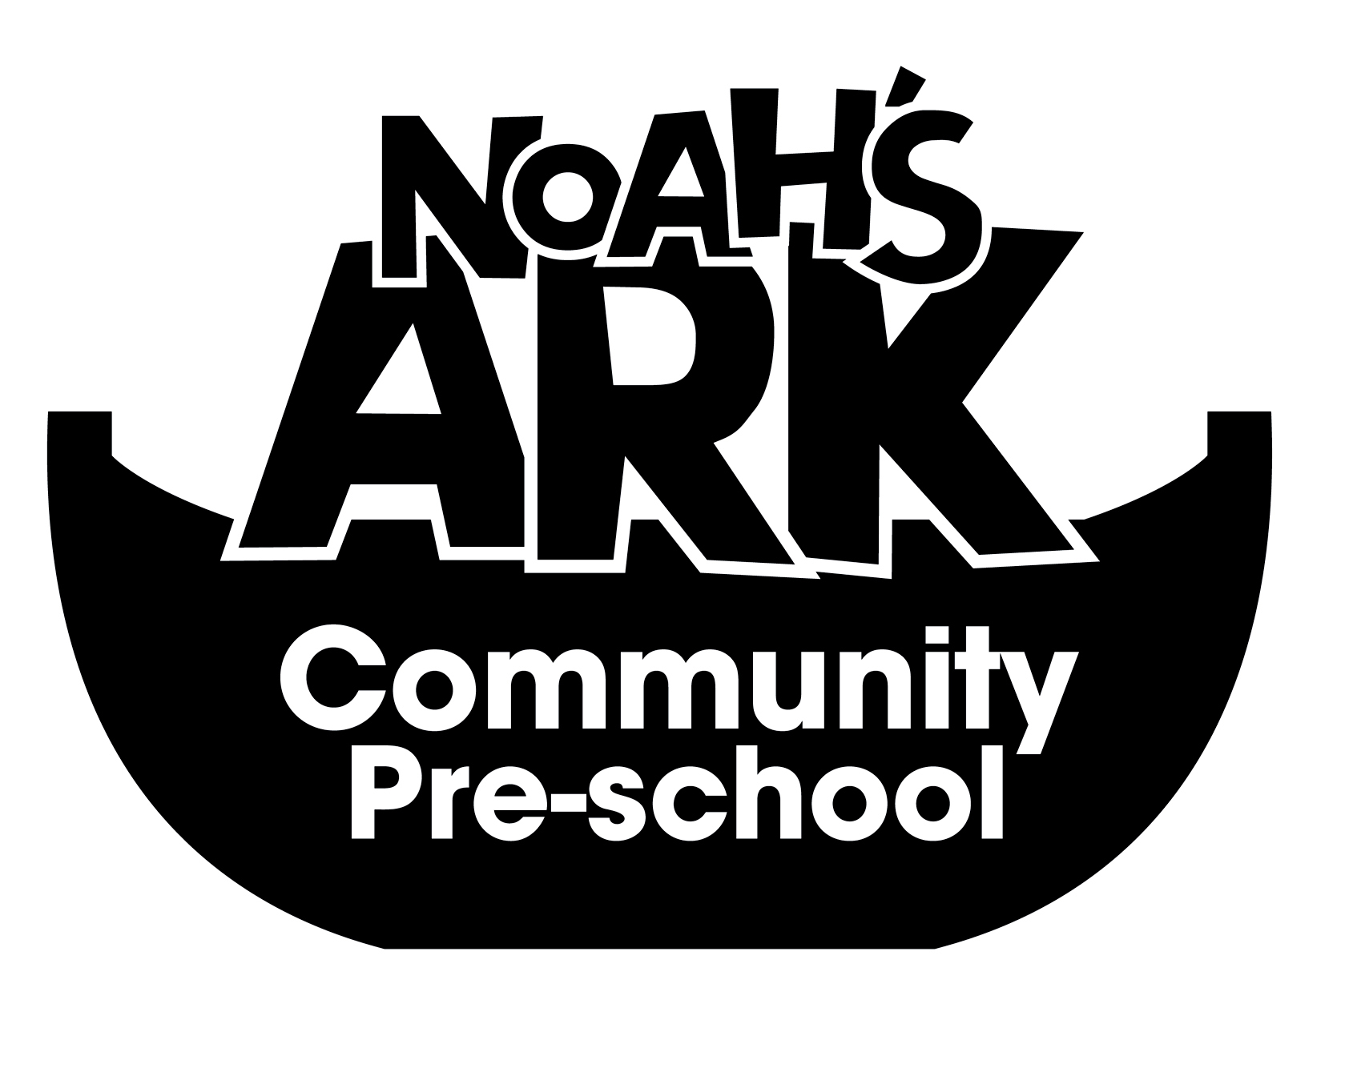

NOAHS ARK COMMUNITY PRE-SCHOOL
18. PARENT AND CARER INVOLVEMENT POLICY
(September 2023)

Parents and carers are the first educators of their children. Our aim is to support and encourage them, not to take over.

New parents and carers will be made aware of the Pre-School systems and policies.

We will encourage parents and carers to contribute their own skills, knowledge and interests to the activities of the group.

Parents and carers will be encouraged to play an active part in the management of the group.

The pre-school will ensure that parents and carers are kept up to date with their child’s progress.

Parents and carers will be involved in shared record keeping about their own child, either formally or informally.

Details of planning and the pre-school’s curriculum will be displayed at all times on the right hand side of the entrance in the playroom.

The Pre-School will advertise all meetings, conferences, workshops and training, on the notice board and parent meetings

Parents and carers will be consulted about the times of meetings to avoid excluding anyone.

The contributions of parents and carers will be welcomed, whatever form these may take.

Parents/carers are welcome to offer verbal contributions and all comments, suggestions and complaints will be treated seriously.

The Pre-School will offer help to parents and carers whose first language is not English.

The Pre-School will use its resource of parents, staff and carers language skills if help is needed.

This policy is reviewed annually
Signed on behalf of the Pre-School: 03/09/2023
Position: Manager

