Noah’s Ark is a small community pre-school set in St Andrew’s church hall. We offer traditional values of family and friendship with a Christian ethos and modern standards in education and care. Noah’s Ark Pre-School Is an Ofsted registered organisation, all children and families are welcome. We provide equal opportunities and inclusive practices for all members of our group, regardless of colour, gender, religion, language, race, ethnicity, or special physical and educational needs. We keep a ratio of staff to children which affords them individual care and attention which is necessary for them to progress at their own rate: in all areas of their learning and development. It is important that parents and staff work together at all times to ensure that individual needs are met. Aims and Mission Statement At Noah’s Ark we aim to meet the child’s individual needs within the group setting, enabling them to make maximum progress towards The Early Learning Goals (ELG) of The Early Years Foundation Stage (EYFS). More importantly we believe that our overall aim is to provide a happy and secure environment in which children can develop personally, socially, and emotionally; recognising that we are the foundation stone upon which their future education is built. We celebrate a child’s uniqueness and encourage respect and social interactions. We strive to promote and encourage independence, self-esteem, tolerance and an awareness of other people’s needs to enabling them to acquire and share values which enrich their lives and those of others. We strive within the limits of the pre-school to provide individual quality care and education for children between the ages of 2 and 5 years, facilitated through enjoyable and varied play in a safe, secure and stimulating learning environment enabling them to reach their full potential. And in consultation with parents/careers, provide a full, broad, balanced and varied curriculum. We employ experienced and well-trained staff to plan, prepare and deliver the curriculum, promote a working partnership between staff, parents/careers and management to help children learn and develop. This supports them through their learning journey and prepare their transition to school.
Policies All our policies are designed to offer the best possible experience for the children and families. They are reviewed on a regular basis. Comments or suggestions are always welcomed from anyone. Our policies and procedures can be found on our website.
Special Educational Needs We aim to provide equality of opportunity for all children at our school this includes children with special educational needs. We are experienced in working in close liaison with professionals across the range of special needs and we operate in accordance with the government’s Code of Practice on special educational needs. Please speak to the pre-school leader or your child’s key worker if you would like to discuss the group’s ability to meet your child’s needs.
Curriculum . Children are supported in developing their full potential; they achieve this at their own pace through appropriate play activities and a high level of individual adult input. We offer a curriculum, which enables children to progress across the seven areas of learning in the Early Years Foundation Stage (EYFS). Some activities are planned half termly in advance; taking into account the different areas of learning, but we place a greater emphasis on the day to day planning that can take into account children’s current interests and individual needs. Children are encouraged to develop their independence at all times and take responsibility for their surroundings. Children should mostly develop the three prime areas first. These are: - Communication and language - Physical development - Personal, social and emotional development. These prime areas are those most essential for your child’s healthy development and future learning. As children grow the prime areas will help them to develop skills in four specific areas. These are: - Literacy - Mathematics - Understanding the world - Expressive arts and design.
Key Worker Groups Your child will be allocated to member of staff who will be their Key Worker. Whilst all the staff will care for all children, Key Workers will take a special interest in their children. At least once a week children will spend time in a small Key Work group, where a planned activity will be offered to them and used to assess their level of understanding: that is how many colours they know or different shapes. Each Key Worker will keep records of achievement on their

children and parents/carers may have access to these at any time. Parents/carers can also contribute towards these records with information of achievements made at home. We provide opportunities for you and your family to be directly involved in the activities of the group and in your own child's progress. By prior arrangement with the pre-school leader parents are welcome to join their child at daily sessions and participate in the activities. For reasons of safety, we are sorry that younger children cannot accompany helpers
Session Times - Term Time Only (3hr sessions) Tuesday to Thursday 9.00am – 12.00pm and 12.30pm – 3.30pm Monday and Friday 9.00am – 12.00pm.
All day Tue –Thursday 8.00am till 4.00pm
Extra hours Mon and Fri 8:00am till 1pm
Fees and Funding Our fees are:
All day 2 year old £56 3 year old £48 Under 3yrs £21 per 3hr session Over 3yrs £18 per 3hr session, Lunch club £3.50 (children bring a packed lunch and drink) Free places: All children over three year qualify for Nursery Education Grant (NEG) for up to 15 hours a week from the term following their 3rd birthday. Two year olds from disadvantaged families may be entitled to receive the NEG currently offered to all three and four year olds, the term after they turn 2. We will claim the cost of funded places on your behalf. Where funding is not received then fees apply.

Noah’s Ark
Community Pre-School
Prospectus
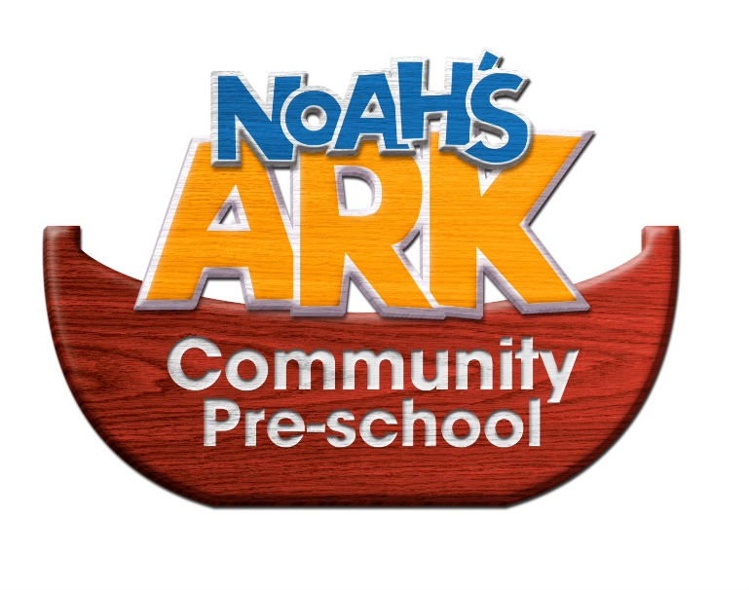
Noah’s Ark Community Pre-School St Andrew’s Church Hall Colworth Road Leytonstone London E11 1JD
noahsarkprescho@gmail.com

